OOP LAB 1

Name : Farhan jaffer

Section : CSE 1

Roll No : 2105714

Q1. WAP to input name , roll number and marks in 5 subjects for a student , and display it.

#include <stdio.h>

int main()

{

struct subjects{

int maths;

int eng;

int sst;

int com;

int hin;

};

struct students{

char name[100];

int roll;

struct subjects sub;

};

struct students student;

printf("\nEnter name: ");

scanf("%s",student.name);

printf("\nEnter Roll: ");

scanf("%d",&student.roll);

printf("\nSubjects for the respective subjects: ");

scanf("%d %d %d %d %d",&student.sub.maths,&student.sub.eng,&student.sub.sst,&student.sub.com,&student.sub.hin);

printf("\nYour Name %s",student.name);

printf("\nYour Roll %d",student.roll);

printf("\nYour Marks = Maths %d Eng %d SST %d Computer %d Hindi %d",student.sub.maths,student.sub.eng,student.sub.sst,student.sub.com,student.sub.hin);

return 0;

}

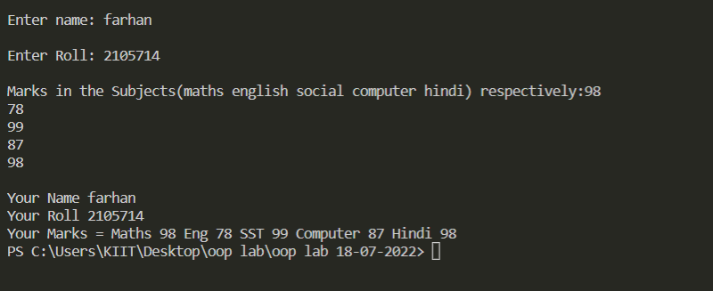

Q2. WAP to input name , roll number and marks in 5 subjects for n number ofstudents . Write functions to :-

1. Find total marks and percentage of all n students .
2. Display details of a student with a given roll number .
3. Display the details for all students having percentage in a given range .
4. Sort the array in ascending order of marks .

#include <stdio.h>

struct subject{

int maths;

int eng;

int sst;

int com;

int hin;

};

struct students{

char name[100];

int roll;

struct subject sub;

};

int main()

{

int numstu;

printf("\nNumber of Students: ");

scanf("%d",&numstu);

struct students student[numstu];

void selection(int *ptr, int length){

for (int i=0;i< length;i++){

int mypt = *(ptr+i);

int minval = *(ptr+i);

int spnt = i;

for (int j=i+1;j< length;j++){

if (*(ptr+j)<=mypt && *(ptr+j)<=minval){

minval = *(ptr+j);

spnt = j;

}

}

*(ptr+i)=minval;

*(ptr+spnt) = mypt;

}

}

void findtotalmarksandpercentage(struct students x[],int total){

int total_marks;

float percentage;

for(int i=0;i<total;i++){

total_marks=x[i].sub.maths+x[i].sub.eng+x[i].sub.sst+x[i].sub.com+x[i].sub.hin;

percentage=total_marks/5;

printf("\n\nTotal_marks(%d) = %d ",i+1,total_marks);

printf("\nPercentage(%d) = %f ",i+1,percentage);

}

}

void displaydetailsrollnum(struct students x[],int total,int roll){

for(int i=0;i<total;i++){

if (x[i].roll==roll){

printf("\nName %s",x[i].name);

printf("\nMark = Maths %d Eng %d SST %d Computer %d Hindi %d ",x[i].sub.maths,x[i].sub.eng,x[i].sub.sst,x[i].sub.com,x[i].sub.hin);

break;

}

}

}

void displaydetailsinrange(struct students x[],int total,int min,int max){

int total_marks;

float percentage[total];

for(int i=0;i<total;i++){

total_marks=x[i].sub.maths+x[i].sub.eng+x[i].sub.sst+x[i].sub.com+x[i].sub.hin;

percentage[i]=total_marks/5;

}

for(int i=0;i<total;i++){

if (percentage[i]>=min & percentage[i]<=max){

printf("\n\nName %s",x[i].name);

printf("\nRoll No. %d",x[i].roll);

printf("\nMark = Maths %d Eng %d SST %d Computer %d Hindi %d ",x[i].sub.maths,x[i].sub.eng,x[i].sub.sst,x[i].sub.com,x[i].sub.hin);

}

}

}

void sortarrayofmarks(struct students x[],int total){

int total_marks[total];

for(int i=0;i<total;i++){

total_marks[i]=x[i].sub.maths+x[i].sub.eng+x[i].sub.sst+x[i].sub.com+x[i].sub.hin;

}

int *ptr = &total_marks;

selection(ptr,sizeof(total_marks) / sizeof(int));

printf("\nSorted Marks ");

for (int x = 0; x < sizeof(total_marks) / sizeof(int); x++){

printf("%d ",total_marks[x]);

}

}

for(int i=0;i<numstu;i++){

printf("\nEnter name(%d): ",i+1);

scanf("%s",student[i].name);

printf("Enter Roll(%d): ",i+1);

scanf("%d",&student[i].roll);

printf("Subjects: ");

scanf("%d %d %d %d %d",&student[i].sub.maths,&student[i].sub.eng,&student[i].sub.sst,&student[i].sub.com,&student[i].sub.hin);

}

findtotalmarksandpercentage(student,numstu);

//displaydetailsrollnum(student,numstu,2);

//displaydetailsinrange(student,numstu,0,20);

//sortarrayofmarks(student,numstu);

return 0;

}

Ans (A)

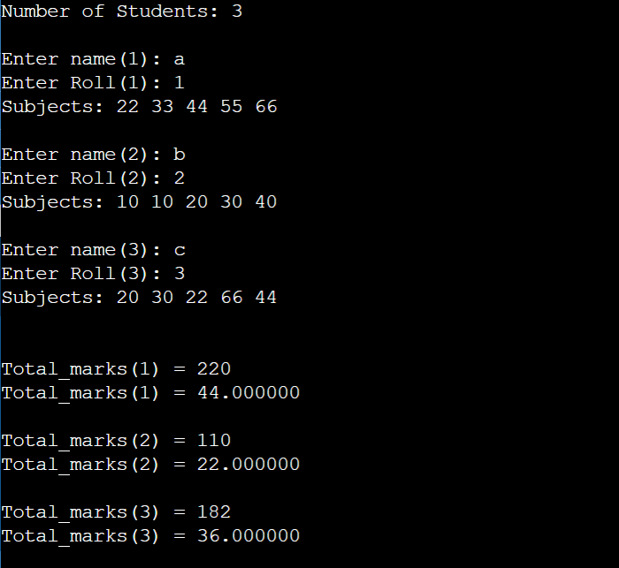

Ans (B)

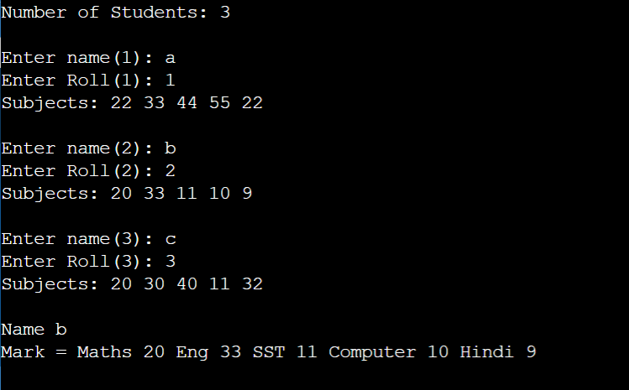

Ans ( 3 )

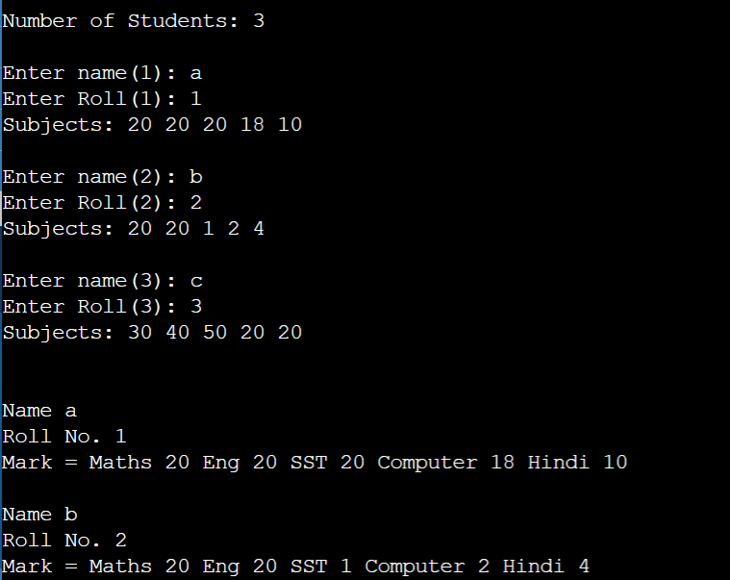

Ans(4)

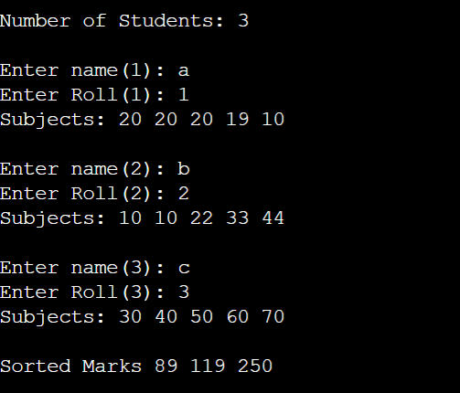

Q3. WAP to enter id, name,age, and basic salary of n number of employees .Calculatethe gross salary of all the employees and display it along with all other

[Gross salary = Basic Salary + DA + HRA ,DA = 80% of Basic salary HRA = 10% of Basic salary ]

#include <stdio.h>

struct employees{

int id;

char name[100];

int age;

int basic_salary;

};

int main()

{

int numstu;

printf("\nNumber of Employee: ");

scanf("%d",&numstu);

struct employees *ptr, employee[numstu];

ptr = &employee;

for(int i=0;i<numstu;i++){

printf("\nEnter Id(%d): ",i+1);

scanf("%d",&employee[i].id);

printf("Enter Name(%d): ",i+1);

scanf("%s",employee[i].name);

printf("Enter Age(%d): ",i+1);

scanf("%d",&employee[i].age);

printf("Enter Basic Salary(%d): ",i+1);

scanf("%d",&employee[i].basic_salary);

}

for(int i=0;i<numstu;i++){

int basic= (ptr+i)->basic_salary;

int gross=basic+basic*0.8+basic*0.1;

printf("\nId: %d Name: %s Age: %d Basic Salary: %d Gross Salary: %d", (ptr+i)->id,

(ptr+i)->name,(ptr+i)->age,(ptr+i)->basic_salary,gross);

}

return 0;

}

